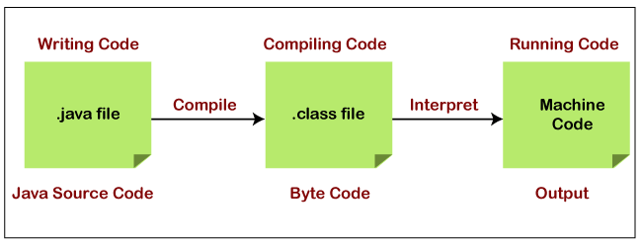Java Interview Prep

**Q1) What is the difference between compiler and interpreter?**

Interpreter translates just one statement of the program at a time into machine code.

Compiler scans the entire program and translates the **whole of it into machine code at once.**

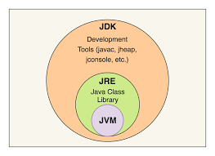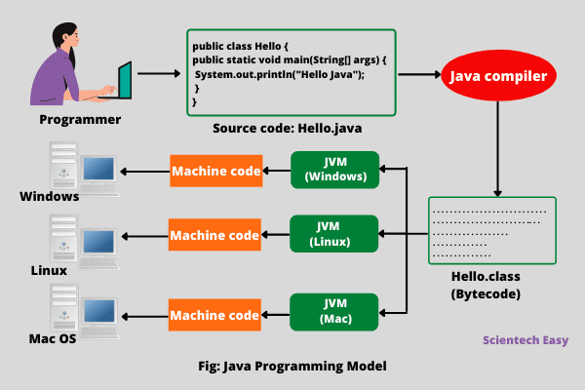Q2) what is JDK and JRE?

Inside the java folder, you will see two more folder that is JDK and JRE.

JDK(Java Development Kit) is used to develop Java applications. JDK also contains numerous development tools like compilers (javac.exe), debuggers, etc.

JRE(Java Runtime Environment) is the implementation of JVM(Java Virtual Machine) and it is specially designed to execute Java programs. It contains java virtual machine(JVM) and java package classes(java liberary).

Q2) what is the significance of data types ?

A type identifies a set of values( and their representation in memory) and a set of operations that transform these values into other values of that set.

Java is strongly typed language

There are two types of data type:

1st Primitive types, 2nd User-defined types.

Primitives types:- these are the data type that java provides in the form of keyword i.e int, float, short, double, byte, Boolean, char, longl.

User-defined types:- these are the data types that defines by the user.